## 5F4E3E92Year 11 Methods Unit 1 Test 2

## Relations, Functions, Linear and Quadratics

Test Date: 30 March 2021

Name: _______________________________________________

___________

36

*All working is to be shown in the space provided. Your working should be in sufficient detail to allow your answers to be checked readily so part marks may be awarded if the answer is incorrect. For any question worth more than 2 marks valid working or justification must be shown to be awarded full marks.*

*Equipment: Pens, pencils, highlighter, ruler, correction tape or fluid, SCSA Formula sheet*

#### SECTION 1 – Resource Free Working Time: 35 minutes

1. State the domain and range of the following functions. **(4 marks)**

|  |  |  |
| --- | --- | --- |
| **RULE** | **DOMAIN** | **RANGE** |
|  |  |  |
|  |  |  |

1. Solve the following equations. **(5 marks)**
   1. (2 marks)
   2. (3 marks)
2. Given and , **(13 marks)**
   1. Find: (3 marks)

|  |  |
| --- | --- |
|  |  |

* 1. Find the value of $t$ if $f\left(t\right)=-17$ (2 marks)
  2. If the domain of $f$ is the set of **integers** between $-2$ and $3$, ie $\{x:-2<x<3, x$ is an integer $\}$ find the range of $f(x)$. (3 marks)
  3. The co-ordinate and nature of the turning point of $g(x)$ and hence sketch on the axes below. (5 marks)

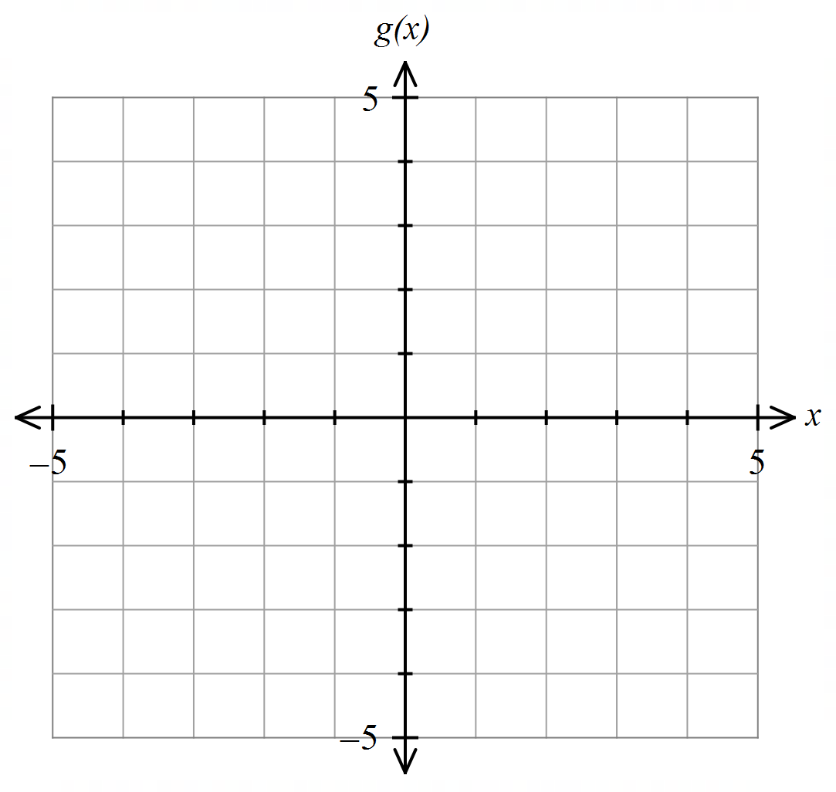

1. Find the equations of the quadratic curves whose graphs are shown below. **(4 marks)**

|  |  |
| --- | --- |
|  |  |

1. **(4 marks)**

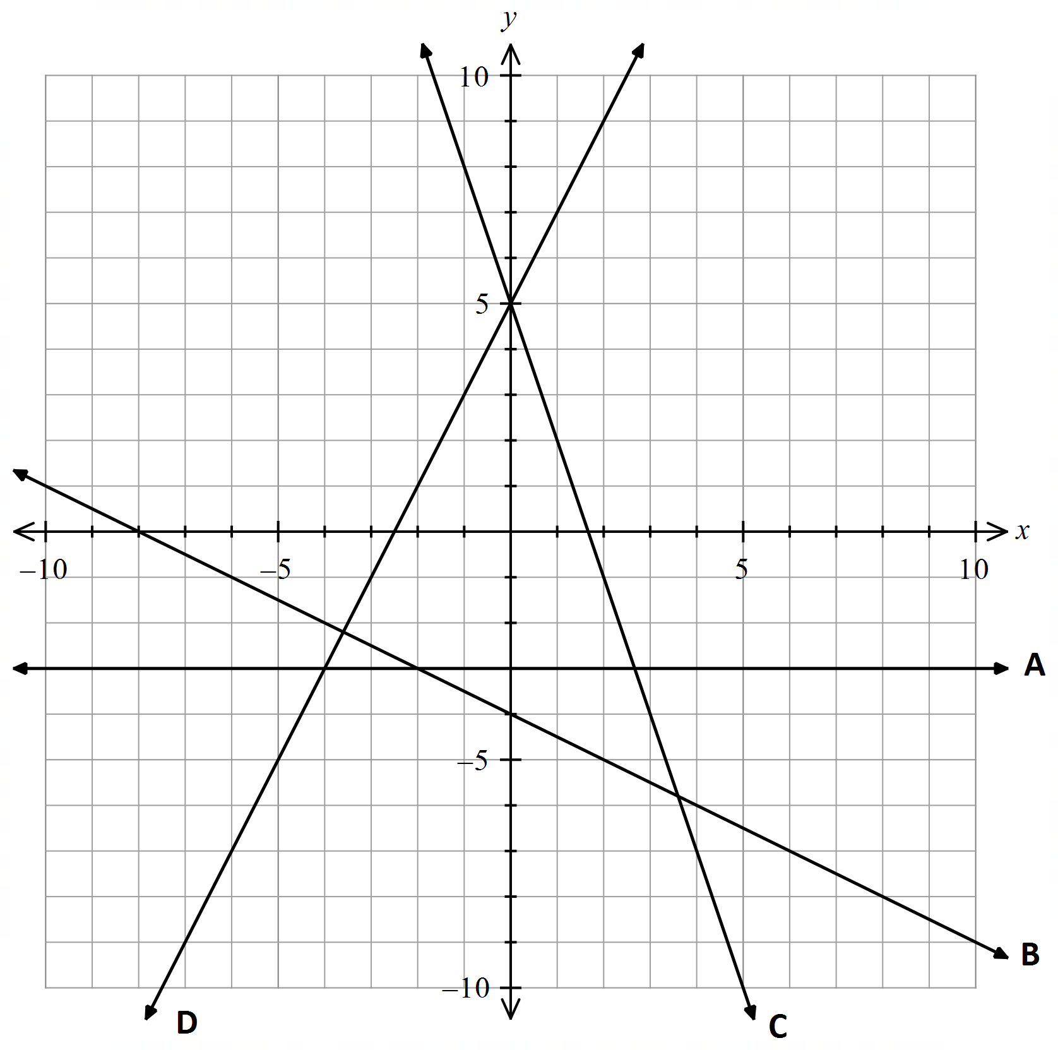The graph shows four linear functions labelled A, B, C and D. Select the correct rule for each function from the list below. Write your answers in the table provided.

NOTE: Not all rules will be used.

|  |  |  |  |  |
| --- | --- | --- | --- | --- |
| Line | A | B | C | D |
| Rule |  |  |  |  |

1. **(6 marks)**

Determine where the following are linear, quadratic or neither. For those that are, linear or quadratic, determine the rule.



|  |  |  |  |  |  |
| --- | --- | --- | --- | --- | --- |
| $x$ | $1$ | $2$ | $3$ | $4$ | $5$ |
| $y$ | 3 |  |  |  |  |



|  |  |  |  |  |  |  |
| --- | --- | --- | --- | --- | --- | --- |
|  | 0 |  |  |  |  |  |
|  |  |  |  |  |  |  |

|  |  |  |  |  |  |
| --- | --- | --- | --- | --- | --- |
|  |  |  |  |  |  |
|  |  |  |  | - |  |

END OF SECTION 1

## 5F4E3E92 Year 11 Methods Unit 1 Test 2

## Relations, Functions, Linear and Quadratics

Test Date: 30 March 2021

Name: _______________________________________________

All working is to be shown in the space provided. Your working should be in sufficient detail to allow your answers to be checked readily so part marks may be awarded if the answer is incorrect. For any question worth more than 2 marks valid working or justification must be shown to be awarded full marks.

***To be provided by the student:***

ClassPad and/or Scientific Calculators, drawing templates1 sheet of A4–sized paper of notes, (double-sided) Retain formula sheet from Section 1

|  |  |  |  |
| --- | --- | --- | --- |
|  |  | Total | **%** |
| Section 1 |  | 36 |
| Section 2 |  | 26 |
| Total |  | 62 |

#### SECTION 2 – Resource Rich Working Time: 20 minutes

1. For the following graphs, state whether an vary with each other (i.e. are directly proportional to each other) or not and, for those cases when direct proportion is involved find the rule for the relationship.

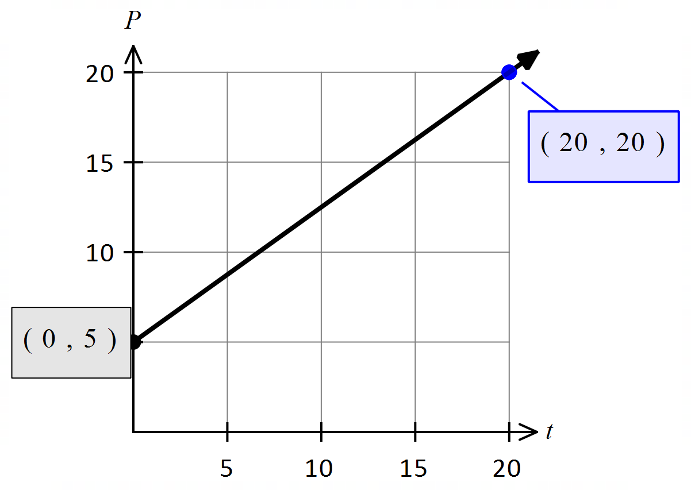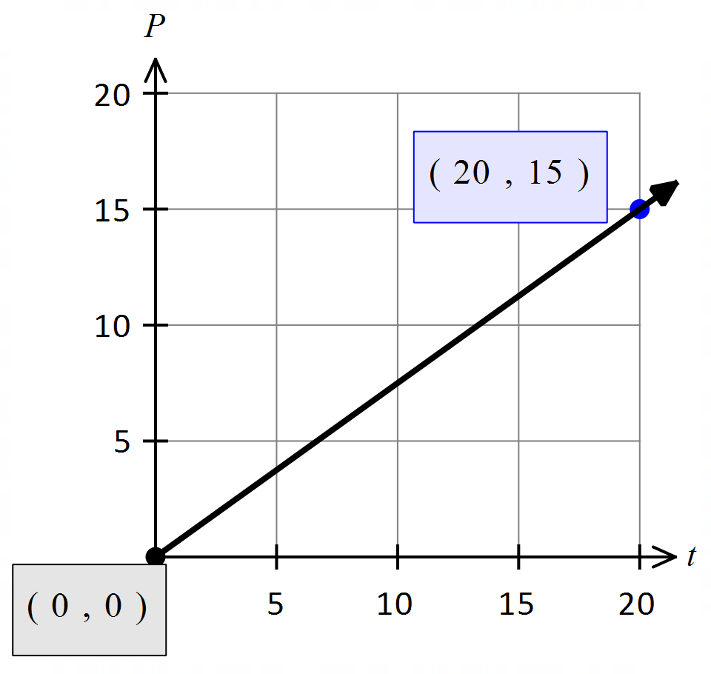 **(2 marks)**





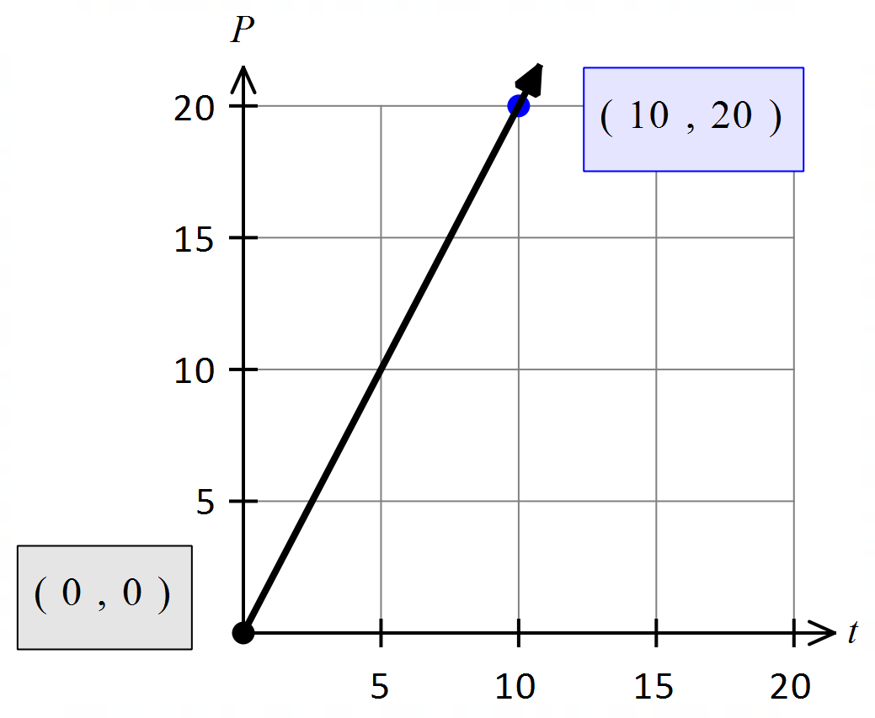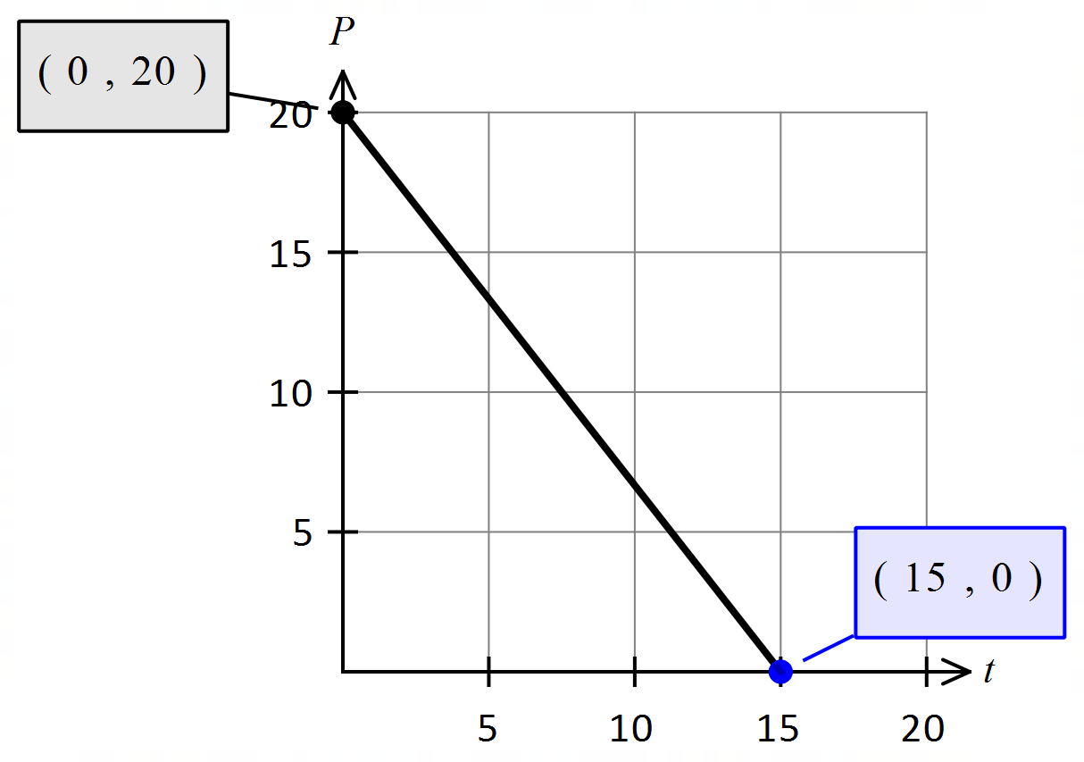

1. The line $L$ passes through the points $A(5, 13)$ and $B(-3, 3)$. Find: **(7 marks)**
   1. The coordinates of $M$, the mid-point of $AB$. (2 marks)
   2. The coordinates of the point $C$, on the line $L$, which is as far from $B$ as $A$ is to $B$. (2 marks)
   3. The equation of the line through $M$ that is parallel to the line $3x+4y=12$. (3 marks)
2. **(4 marks)**
   1. Find the equation of the line that passes through the point $(1, 12)$ and is perpendicular to $y=$ $–2x+4$.

(2 marks)

* 1. Find the value(s) of $k$ if the following points are collinear. $(-2, -4), (k, 4)$ and $(6, 10)$ (2 marks)

1. Determine whether the following are functions. **(4 marks)**

|  |  |
| --- | --- |
| $\left(2, -1\right), \left(5, 12\right), \left(-2, 11\right), \left(1, 6\right), \left(0, 11\right)$ | $\left(7, 3\right), \left(-3, 2\right), \left(1, -3\right), \left(7, 5\right), \left(-1, 0\right)$ |
| $x^{2}+y^{2}=4$ | $y=\frac{12x}{\sqrt{x-1}}$ |
| $3x^{2}+2y=7$ |  |
|  |  |

1. The vertices of a triangle have the coordinates $A(2, 4)$, B $(7, 4)$ and $C(7, 2)$**(4 marks)**

Determine the gradient of each side of the triangle to confirm this is right triangle and state which vertex is right angled.

1. **(5 marks)**

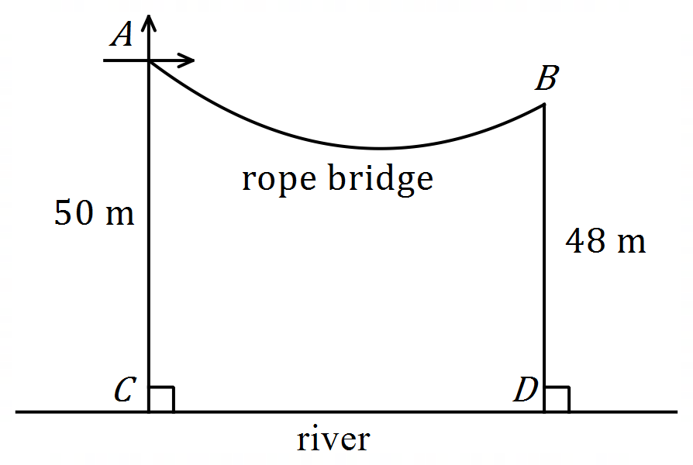A rope suspension bridge is constructed between the edges $A$ and $B$ of a river gorge. Point $A$ is 50 metres above the river and point is 48 metres above the river.

and are in the same vertical plane with directly below .

Using as the origin of the Cartesian co-ordinate axes, the rope bridge between and can be modelled by the equation:

.

* 1. Find the height of the lowest point of the rope bridge above the river. (2 marks)
  2. Find the width of the gorge from $C$ to $D$. (3 marks)

END OF SECTION 2

## 5F4E3E92Year 11 Methods Unit 1 Test 2

## Relations, Functions, Linear and Quadratics

Test Date: 30 March 2021

Name: SOLUTIONS

___________

36

All working is to be shown in the space provided. Your working should be in sufficient detail to allow your answers to be checked readily so part marks may be awarded if the answer is incorrect. For any question worth more than 2 marks valid working or justification must be shown to be awarded full marks.

*Equipment: Pens, pencils, highlighter, ruler, correction tape or fluid, SCSA Formula sheet*

#### SECTION 1 – Resource Free Working Time: 35 minutes

1. State the domain and range of the following functions. **(4 marks)**

|  |  |  |
| --- | --- | --- |
| **RULE** | **DOMAIN** | **RANGE** |
|  | ✓ | ✓ |
|  |  | ✓ |

1. Solve the following equations. **(5 marks)**
   1. (2 marks)

✓

✓

* 1. (3 marks)

✓

✓

✓

1. Given and , **(13 marks)**
   1. Find: (3 marks)

|  |  |
| --- | --- |
| ✓ | ✓    ✓ |

* 1. Find the value of if (2 marks)

✓

✓

* 1. If the domain of $f$ is the set of **integers** between $-2$ and $3$, ie $\{x:-2<x<3, x$ is an integer $\}$ find the range of $f(x)$. (3 marks)

Need $f\left(-1\right),f\left( 0\right), f\left(1\right), f(2)$

$f\left(-1\right)=8$

$f\left(0\right)=10$

$f\left(1\right)=12$

$f\left(2\right)=14$

$∴$ range is

✓✓✓ all correct integers,

✓✓ correctly shows integers but not correct range

✓ if correct range but not specified integers

* 1. Find the co-ordinate and nature of the turning point of $g(x)$ and hence sketch on the axes below.   
      (5 marks)

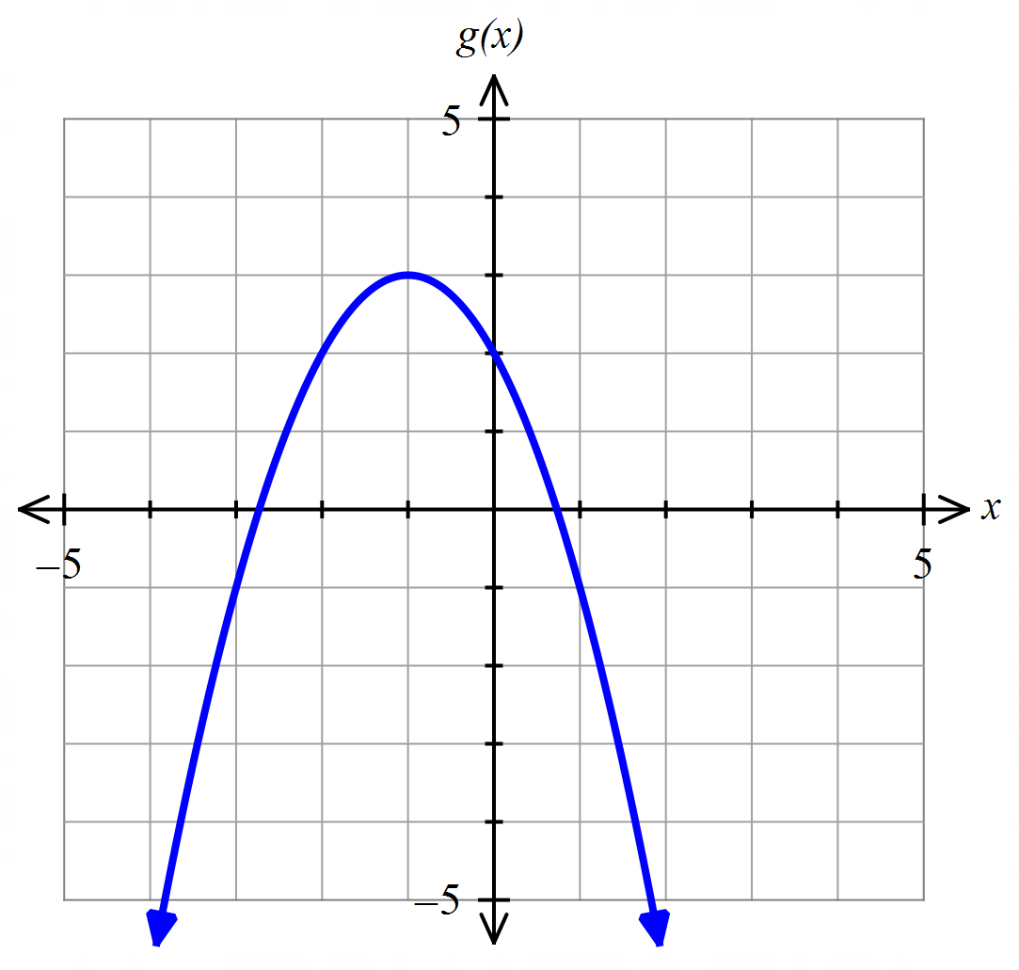

✓

✓

✓

✓ y int

✓ TP

✓ correct shape

1. Find the equations of the quadratic curves whose graphs are shown below. **(4 marks)**

|  |  |
| --- | --- |
| ✓  ✓ | 3 ✓  ✓ |

1. **(4 marks)**

The graph shows four linear functions labelled A, B, C and D. Select the correct rule for each function from the list below. Write your answers in the table provided.

NOTE: Not all rules will be used.

|  |  |  |  |  |
| --- | --- | --- | --- | --- |
| Line | A | B | C | D |
| Rule | ✓ | ✓ | ✓ | ✓ |

1. **(6 marks)**

Determine where the following are linear, quadratic or neither. For those that are linear or quadratic, determine the rule.



|  |  |  |  |  |  |
| --- | --- | --- | --- | --- | --- |
| $x$ | $1$ | $2$ | $3$ | $4$ | $5$ |
| $y$ | 3 | $9$ | $27$ | $81$ | $243$ |

Constant ratio therefore not a linear or quadratic function ✓



|  |  |  |  |  |  |  |
| --- | --- | --- | --- | --- | --- | --- |
|  | 0 | $1$ | $2$ | $3$ | $4$ | $5$ |
| $y$ | $$-2$$ | $2$ | $8$ | $$16$$ | $$26$$ | $$38$$ |

4 6 8 10 12

2 2 2 2

Constant second difference therefore quadratic

✓

✓

✓

|  |  |  |  |  |  |
| --- | --- | --- | --- | --- | --- |
|  |  |  |  |  |  |
|  |  |  |  | - |  |

|  |  |  |  |  |  |
| --- | --- | --- | --- | --- | --- |
|  | 0 $1$ | $$2$$ | $$3$$ | $$4$$ | $$5$$ |
| $$y$$ | 9 $7$ | $$5$$ | $$3$$ | $$1$$ | - $1$ |

-2 -2 -2 -2

Constant first difference therefore linear

$m=-2$ $c=9$

$y=-2x+9$

END OF SECTION 1

## 5F4E3E92 Year 11 Methods Unit 1 Test 2

## Relations, Functions, Linear and Quadratics

Test Date: 30 March 2021

Name: _______________________________________________

All working is to be shown in the space provided. Your working should be in sufficient detail to allow your answers to be checked readily so part marks may be awarded if the answer is incorrect. For any question worth more than 2 marks valid working or justification must be shown to be awarded full marks.

***To be provided by the student:***

ClassPad and/or Scientific Calculators, drawing templates1 sheet of A4–sized paper of notes, (double-sided) Retain formula sheet from Section 1

|  |  |  |  |
| --- | --- | --- | --- |
|  |  | Total | **%** |
| Section 1 |  | 36 |
| Section 2 |  | 26 |
| Total |  | 62 |

#### SECTION 2 – Resource Rich Working Time: 20 minutes

1. For the following graphs, state whether an vary with each other (i.e. are directly proportional to each other) or not and, for those cases when direct proportion is involved find the rule for the relationship.

 **(2 marks)**

Direct proportion ✓ not direct proportion



Not direct proportion direct proportion ✓

1. The line $L$ passes through the points $A(5, 13)$ and $B(-3, 3)$. Find: **(7 marks)**
   1. The coordinates of $M$, the mid-point of $AB$. (2 marks)

✓✓

* 1. The coordinates of the point , on the line , which is as far from as is to . (2 marks)

✓✓

* 1. The equation of the line through $M$ that is parallel to the line $3x+4y=12$. (3 marks)

✓

✓

✓ (or $y=-0.75x+8.75$ or $4y+3x=35$)

1. **(4 marks)**
   1. Find the equation of the line that passes through the point $(1, 12)$ and is perpendicular to $y=$ $–2x+4$.

(2 marks)

✓

✓

* 1. Find the value(s) of $k$ if the following points are collinear. $(-2, -4), (k, 4)$ and $(6, 10)$ (2 marks)

✓

✓

1. Determine whether the following are functions. **(4 marks)**

|  |  |
| --- | --- |
| $\left(2, -1\right), \left(5, 12\right), \left(-2, 11\right), \left(1, 6\right), \left(0, 11\right)$ | $\left(7, 3\right), \left(-3, 2\right), \left(1, -3\right), \left(7, 5\right), \left(-1, 0\right)$ Not function one to many ✓ |
| Not function one to many ✓ |  |
|  | Not function fails vertical line test ✓ |
| Not function infinite values for $y$ for each $x$ value ✓ |  |

1. The vertices of a triangle have the coordinates $A(2, 4)$, B $(7, 4)$ and $C(7, 2)$**(4 marks)**

Determine the gradient of each side of the triangle to confirm this is right triangle and state which vertex is right angled.

✓

✓

✓

Right angled at ✓

1. (5 marks)

A rope suspension bridge is constructed between the edges $A$ and $B$ of a river gorge. Point $A$ is 50 metres above the river and point is 48 metres above the river.

and are in the same vertical plane with directly below .

Using as the origin of the Cartesian co-ordinate axes, the rope bridge between and can be modelled by the equation:

.

* 1. Find the height of the lowest point of the rope bridge above the river. (2 marks)

✓

m ✓

* 1. Find the width of the gorge from $C$ to $D$. (3 marks)

✓

✓

50 m✓

END OF SECTION 2